# 

**DOCUMENTATION GUIDE**

**FOR VISUALIZATION**

**BY,**

**NAME: RENGA PRASAD A**

**GITHUB LINK :** [**https://github.com/Renga- 1002/Shadow-Fox-/blob/main/shadow-fox-task-1.ipynb**](https://github.com/Renga-%09%09%09%09%09%09%09%091002/Shadow-Fox-/blob/main/shadow-fox-task-1.ipynb%09%09%09%09%09%09%091002/Shadow-Fox-/blob/main/shadow-fox-task-1.ipynb)

# SHADOW FOX

**Python Visualization Libraries: Matplotlib and Seaborn**

**Matplotlib**

Matplotlib is one of the most widely used plotting libraries in Python. It is known for its flexibility and the wide range of visualizations it can produce. It is highly customizable and can generate publication-quality figures in various formats.

**Key Features:**

* Versatile and powerful for creating static, animated, and interactive visualizations.
* Highly customizable through a plethora of parameters and options.
* Can produce figures in multiple formats such as PNG, PDF, SVG, etc.
* Compatible with various GUI toolkits like Tkinter, wxPython, and Qt.

**Typical Use Cases:**

* Academic and scientific research for creating publication-quality figures.
* Data analysis and exploration.
* Customizable plots for specific visualization needs.

**Seaborn**

Seaborn is a high-level statistical data visualization library based on Matplotlib. It provides a more straightforward interface for creating aesthetically pleasing and informative statistical graphics. It integrates closely with Pandas data structures, making it ideal for exploratory data analysis.

**Key Features:**

* Simplified syntax for creating complex plots.
* Beautiful default styles and color palettes to enhance visual appeal.
* Built-in support for complex visualizations like violin plots, box plots, and heatmaps.
* Facilitates easy visualization of statistical relationships.

**Typical Use Cases:**

* Exploratory data analysis.
* Statistical data visualization.
* Quick and beautiful visualizations for data insights.

# 

# Graph Types

# Matplotlib

**1. Line Plot**

**Description:** A line plot is useful for visualizing trends over time or ordered categories.

**Use Case:** Visualizing time series data, such as stock prices over time.

import matplotlib.pyplot as plt  
  
# Sample data  
x = [0, 1, 2, 3, 4, 5]  
y = [0, 1, 4, 9, 16, 25]  
  
# Create line plot  
plt.plot(x, y)  
plt.xlabel('X-axis')  
plt.ylabel('Y-axis')  
plt.title('Line Plot Example')  
plt.show()

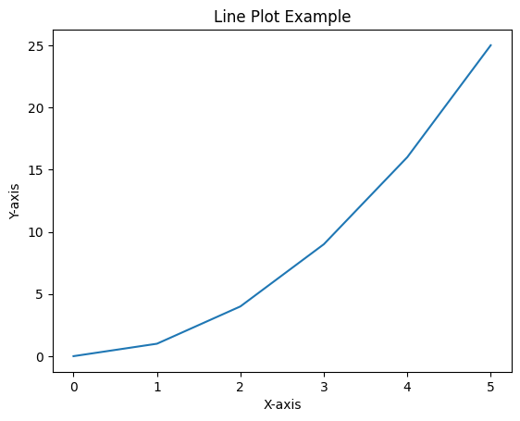

**2. Scatter Plot**

**Description:** A scatter plot displays points based on two variables' values to identify correlations or patterns.

**Use Case:** Visualizing the relationship between two continuous variables.

**EXAMPLE:**

import matplotlib.pyplot as plt  
  
# Sample data  
x = [1, 2, 3, 4, 5]  
y = [5, 4, 3, 2, 1]  
  
# Create scatter plot  
plt.scatter(x, y)  
plt.xlabel('X-axis')  
plt.ylabel('Y-axis')  
plt.title('Scatter Plot Example')  
plt.show()

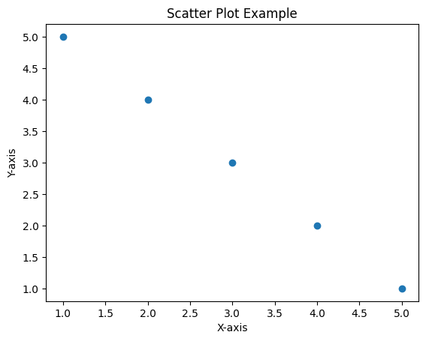

**3. Bar Chart**

**Description:** A bar chart is used to compare different categories or groups.

**Use Case:** Comparing the sales of different products.

import matplotlib.pyplot as plt  
  
# Sample data  
categories = ['A', 'B', 'C', 'D']  
values = [10, 20, 15, 5]  
  
# Create bar chart  
plt.bar(categories, values)  
plt.xlabel('Categories')  
plt.ylabel('Values')  
plt.title('Bar Chart Example')  
plt.show()

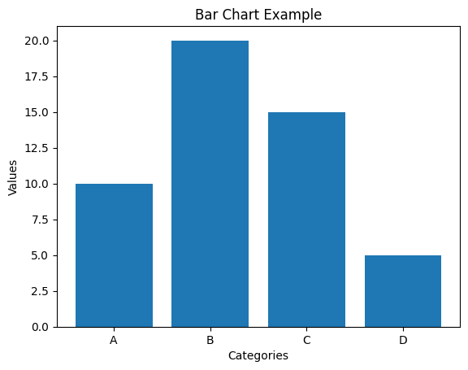

**4. Histogram**

**Description:** A histogram displays the distribution of a dataset.

**Use Case:** Analyzing the distribution of test scores.

import matplotlib.pyplot as plt  
  
# Sample data  
data = [1, 2, 2, 3, 3, 3, 4, 4, 4, 4, 5, 5, 5, 5, 5]  
  
# Create histogram  
plt.hist(data, bins=5)  
plt.xlabel('Value')  
plt.ylabel('Frequency')  
plt.title('Histogram Example')  
plt.show()

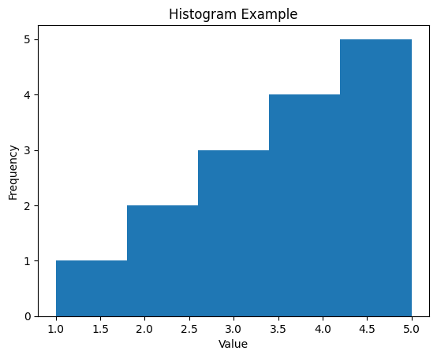

**5. Pie Chart**

**Description:** A pie chart shows the proportions of a whole, divided into slices.

**Use Case:** Visualizing the market share of different companies.

import matplotlib.pyplot as plt  
  
# Sample data  
labels = ['A', 'B', 'C', 'D']  
sizes = [15, 30, 45, 10]  
  
# Create pie chart  
plt.pie(sizes, labels=labels, autopct='%1.1f%%')  
plt.title('Pie Chart Example')  
plt.show()

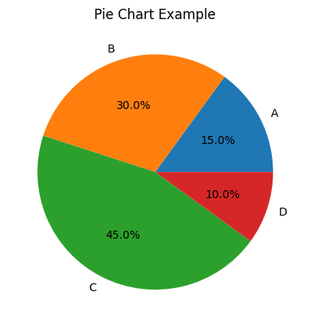

**6. Box Plots**

**Description:** Box plots display the distribution of a dataset based on a five-number summary.

**Use Case:** Comparing distributions between groups.

import matplotlib.pyplot as plt  
  
data = [1, 2, 3, 4, 5, 6, 7, 8, 9]  
  
plt.boxplot(data)  
plt.title("Box Plot")  
plt.show()

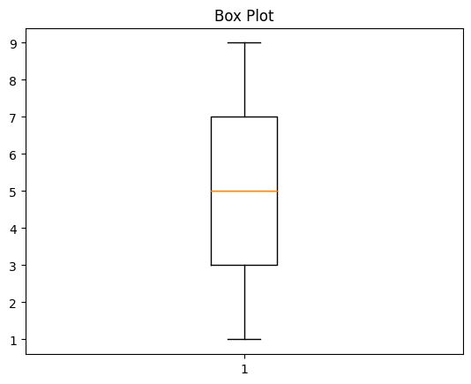

**7. Heat maps**

**Description:** Heatmaps display data in matrix form, using colors to represent values.

**Use Case:** Visualizing correlations or frequencies.

import matplotlib.pyplot as plt  
import numpy as np  
  
data = np.random.rand(10, 10)  
  
plt.imshow(data, cmap='hot', interpolation='nearest')  
plt.title("Heatmap")  
plt.colorbar()  
plt.show()

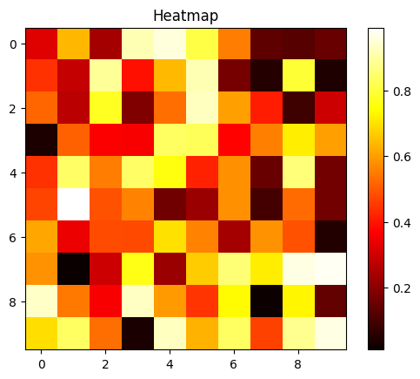

# Seaborn

**1. Line Plot**

**Description:** A line plot in Seaborn provides easy-to-use methods for visualizing trends.

**Use Case:** Showing time series data with statistical estimates.

import seaborn as sns  
import matplotlib.pyplot as plt  
  
# Sample data  
data = sns.load_dataset("flights")  
  
# Create line plot  
sns.lineplot(x="year", y="passengers", data=data)  
plt.title('Seaborn Line Plot Example')  
plt.show()

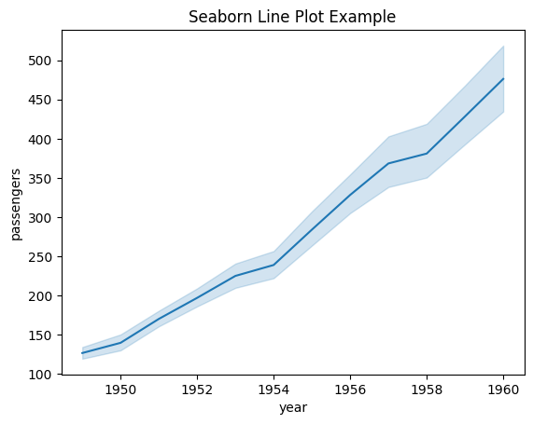

**2. Scatter Plot**

**Description:** Seaborn’s scatter plot provides enhanced visualization of data points with regression lines.

**Use Case:** Investigating the relationship between two numerical variables.

import seaborn as sns  
import matplotlib.pyplot as plt  
  
# Sample data  
data = sns.load_dataset("tips")  
  
# Create scatter plot  
sns.scatterplot(x="total_bill", y="tip", data=data)  
plt.title('Seaborn Scatter Plot Example')  
plt.show()

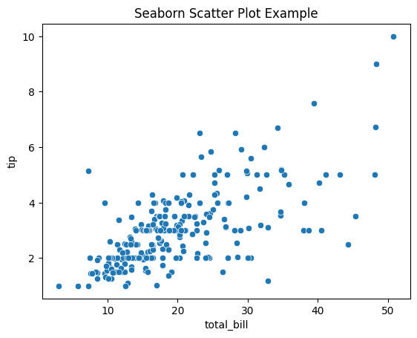

**3. Bar Chart**

**Description:** Seaborn’s bar chart automatically computes and represents statistical values.

**Use Case:** Comparing categorical data with statistical aggregation.

import seaborn as sns  
import matplotlib.pyplot as plt  
  
# Sample data  
data = sns.load_dataset("tips")  
  
# Create bar chart  
sns.barplot(x="day", y="total_bill", data=data)  
plt.title('Seaborn Bar Chart Example')  
plt.show()

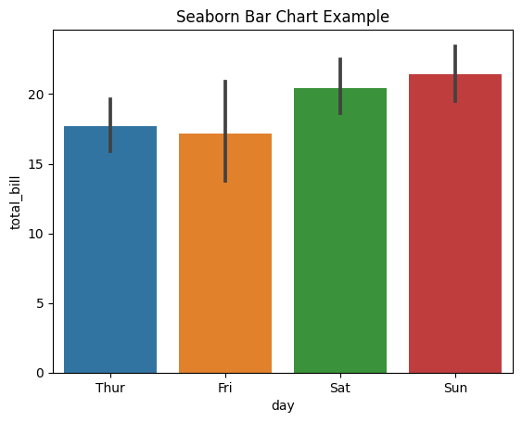

**4. Histogram**

**Description:** Seaborn’s histogram (distplot) offers a refined view of data distribution.

**Use Case:** Understanding the distribution and density of a dataset.

import seaborn as sns  
import matplotlib.pyplot as plt  
  
# Sample data  
data = sns.load_dataset("iris")  
  
# Create histogram  
sns.histplot(data["sepal_length"], kde=True)  
plt.title('Seaborn Histogram Example')  
plt.show()

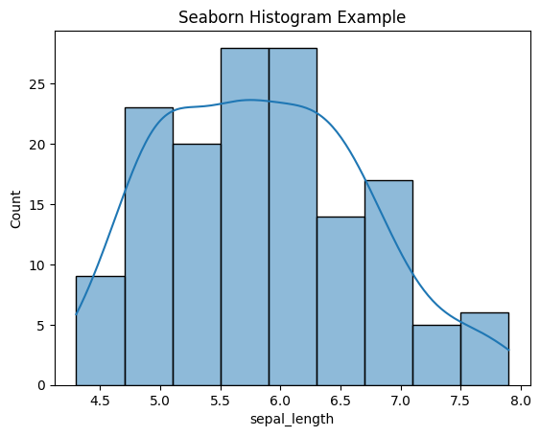

**5. Heatmap**

**Description:** A heatmap displays matrix-like data, highlighting variations in intensity.

**Use Case:** Visualizing correlation matrices or frequency tables.

import seaborn as sns  
import matplotlib.pyplot as plt  
  
# Sample data  
data = sns.load_dataset("flights")  
pivot_data = data.pivot(index="month", columns="year", values="passengers")  
  
# Create heatmap  
sns.heatmap(pivot_data, annot=True, fmt="d")  
plt.title('Seaborn Heatmap Example')  
plt.show()

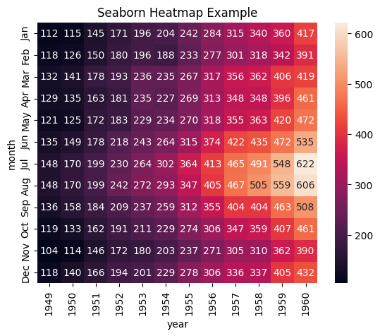

**6.Box plots**

**Description:** Seaborn simplifies the creation of box plots with enhanced aesthetics.

**Use Case:** Detailed comparison of distributions between categories.

import seaborn as sns  
import pandas as pd  
  
data = pd.DataFrame({  
 "category": ['A']*10 + ['B']*10,  
 "value": [1, 2, 3, 4, 5, 6, 7, 8, 9, 10, 2, 3, 4, 5, 6, 7, 8, 9, 10, 11]  
})  
  
sns.boxplot(data=data, x="category", y="value")  
plt.title("Box Plot")  
plt.show()

# 

**7. Pair plots**

**Description:** Pair plots visualize pairwise relationships in a dataset.

**Use Case:** Exploring relationships between multiple variables.

import seaborn as sns  
import pandas as pd  
  
data = pd.DataFrame({  
 "A": [1, 2, 3, 4, 5],  
 "B": [5, 4, 3, 2, 1],  
 "C": [2, 3, 4, 5, 6]  
})  
  
sns.pairplot(data)  
plt.title("Pair Plot")  
plt.show()

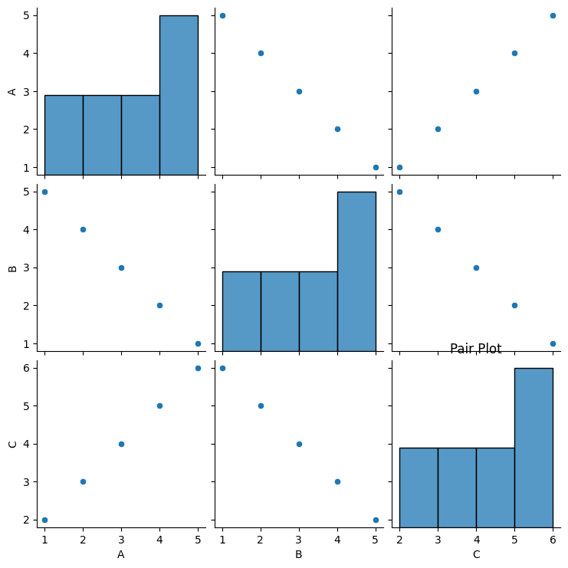

**8. Violin plots**

**Description:** Violin plots combine box plot and KDE.

**Use Case:** Comparing distributions with kernel density

import seaborn as sns  
import pandas as pd  
  
data = pd.DataFrame({  
 "category": ['A']*10 + ['B']*10,  
 "value": [1, 2, 3, 4, 5, 6, 7, 8, 9, 10, 2, 3, 4, 5, 6, 7, 8, 9, 10, 11]  
})  
  
sns.violinplot(data=data, x="category", y="value")  
plt.title("Violin Plot")  
plt.show()

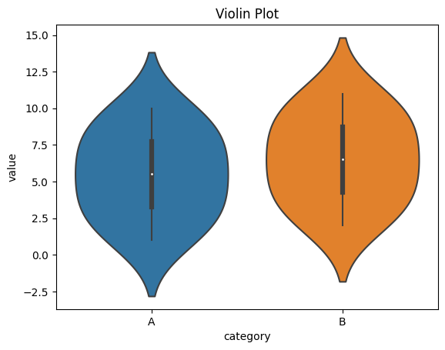

**9. Swarm plots**

**Description:** Swarm plots display individual data points along with distribution.

**Use Case:** Detailed visualization of data points and their distribution.

import seaborn as sns  
import pandas as pd  
  
data = pd.DataFrame({  
 "category": ['A']*10 + ['B']*10,  
 "value": [1, 2, 3, 4, 5, 6, 7, 8, 9, 10, 2, 3, 4, 5, 6, 7, 8, 9, 10, 11]  
})  
  
sns.swarmplot(data=data, x="category", y="value")  
plt.title("Swarm Plot")  
plt.show()

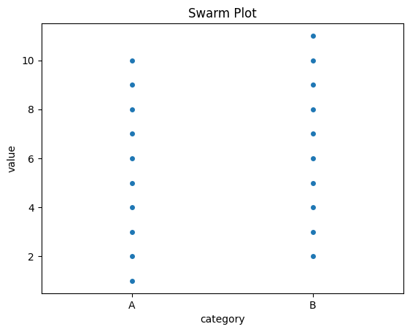

# Strengths and Weaknesses of Matplotlib and Seaborn

# Matplotlib

**Strengths**

**Flexibility and Control:**

* Matplotlib provides a high degree of control over every aspect of a plot, allowing users to create highly customized visualizations.
* It can produce publication-quality figures in various formats and styles.

**Versatility:**

* Capable of generating a wide range of plots, including line plots, scatter plots, bar charts, histograms, pie charts, 3D plots, and more.
* Supports animations and interactive plots through additional libraries like mpl_toolkits and matplotlib.animation.

**Integration:**

* Integrates well with other libraries in the Python ecosystem, such as NumPy, Pandas, and SciPy.
* Compatible with various GUI toolkits like Tkinter, wxPython, and Qt for embedding plots in applications.

**Large Community and Documentation:**

* Extensive documentation and a large user community provide numerous examples, tutorials, and resources for troubleshooting.

**Weaknesses**

**Complexity:**

* The high degree of customization can make Matplotlib complex and verbose, requiring more code for simple plots compared to high-level libraries.

**Default Styles:**

* The default styles and aesthetics of Matplotlib plots can appear outdated and less visually appealing compared to more modern libraries like Seaborn and Plotly.

**Interactivity:**

* Basic interactivity is supported, but it is not as seamless or advanced as libraries like Plotly or Bokeh, which are designed with interactivity in mind.

**Performance with Large Datasets:**

* Can become slow when handling very large datasets, particularly for interactive visualizations.

# 

# Seaborn

**Strengths**

**Ease of Use:**

* Simplifies the creation of complex statistical plots with minimal code, making it accessible for quick data visualization and exploration.
* High-level interface abstracts much of the complexity involved in creating detailed plots.

**Aesthetics:**

* Provides beautiful default styles and color palettes that enhance the visual appeal of plots without requiring additional customization.
* Automatically adjusts plots to include informative elements such as confidence intervals and trend lines.

**Integration with Pandas:**

* Seamlessly integrates with Pandas data structures, making it easy to create visualizations directly from DataFrames.

**Statistical Visualization:**

* Specializes in statistical data visualization, offering built-in functions for complex plots like violin plots, box plots, and heatmaps.

**Weaknesses**

**Limited Customization:**

* While Seaborn offers many customization options, it is less flexible than Matplotlib when it comes to detailed adjustments and unique plot requirements.

**Dependency on Matplotlib:**

* Seaborn is built on top of Matplotlib, so understanding Matplotlib is often necessary for advanced customizations.

**Performance with Large Datasets:**

* May struggle with very large datasets due to its high-level nature and additional statistical computations, which can be resource-intensive.

**Interactivity:**

* Primarily focused on static plots and does not offer built-in interactivity features. Users need to use Matplotlib’s interactive capabilities or other libraries for interactivity.

# Comparison

**Ease of Use**

* **Matplotlib:** Highly customizable but requires more code for basic plots.
* **Seaborn:** Simplifies the process of creating attractive and informative plots with minimal code.

**Customization Options**

* **Matplotlib:** Extensive customization options, allowing for detailed and specific visual adjustments.
* **Seaborn:** Provides fewer customization options compared to Matplotlib but offers beautiful default settings.

**Interactivity**

* **Matplotlib:** Basic interactive capabilities, often used with additional tools for enhanced interactivity.
* **Seaborn:** Primarily focused on static plots, but can integrate with Matplotlib's interactive features.

**Performance with Large Datasets**

* **Matplotlib:** Handles large datasets reasonably well but can become slow with very large data.
* **Seaborn:** Generally efficient with moderate-sized datasets but can struggle with very large datasets due to its high-level nature.

# Summary

* Matplotlib is best suited for users who need complete control over their visualizations, require a wide range of plot types, and are comfortable writing more verbose code for customization. It is ideal for creating publication-quality figures and integrating with other Python libraries and GUI applications.
* Seaborn is designed for quick and beautiful statistical data visualization with less code, making it ideal for exploratory data analysis. It is especially useful when working with Pandas DataFrames and when default aesthetics and statistical elements are sufficient.